Define Problem Statement
Urban metro systems serve thousands of passengers every day. During peak hours, passengers often experience long queues at ticket counters, delays in ticket issuance, manual fare calculation errors, and inconvenience caused by cash-based transactions. These issues reduce operational efficiency and negatively impact the overall passenger experience.
To address these challenges, there is a need for a digital, automated, and user-friendly metro ticketing solution that simplifies ticket booking while improving efficiency for both passengers and metro administrators.

Problem Statement :
The existing metro ticket booking process relies heavily on manual operations, resulting in longer waiting times, inefficient fare calculation, limited digital accessibility, and increased operational workload. Additionally, maintaining passenger records manually makes it difficult to monitor ticket transactions and generate meaningful operational insights.
There is a need to develop a centralized Metro Ticket Generating System that automates ticket booking, fare calculation, QR code generation, and data management while ensuring secure access and a seamless user experience.

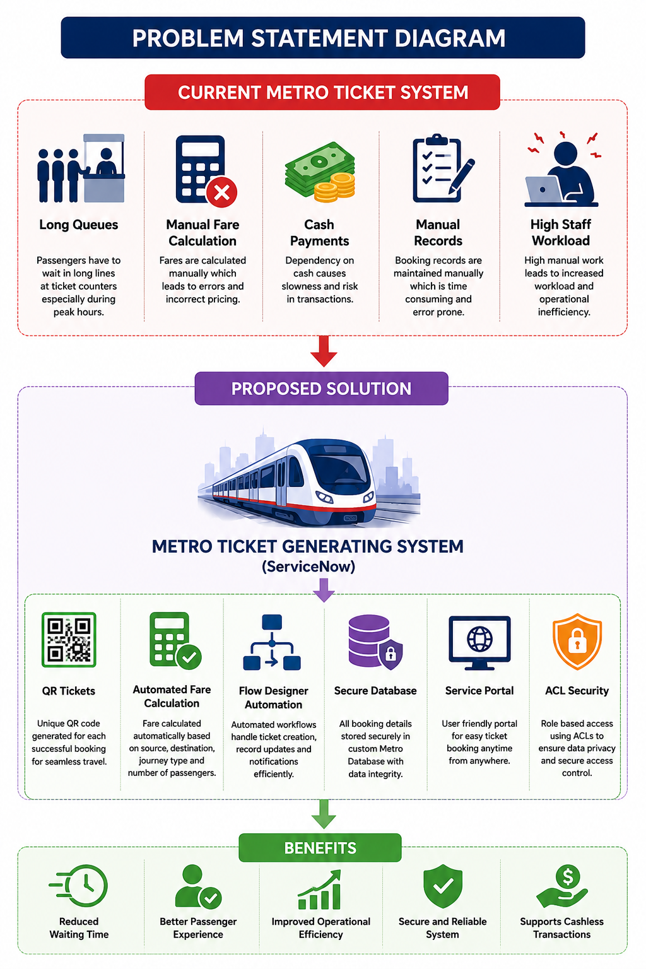

Conclusion:
The Metro Ticket Generating System addresses the key limitations of traditional metro ticketing by introducing automation, digital ticket generation, secure data management, and an improved user experience. Implementing this solution on the ServiceNow platform enables efficient ticket management while providing a scalable foundation for future enhancements such as payment gateway integration, SMS notifications, and travel analytics.

